Early Years Sensory Plan
My Sensory Plan  Date: | Name |  | DOB
My Sensory Plan  Date: | Completed by |  | Review date
Photo of my preferred sensory resources

Sensory Input | Sensory aversives (Assess)  ‘I may avoid’ | Sensory preferences (Assess)  ‘I may seek’ | What helps me regulate (Plan/Do)

Sight


Smell


Taste

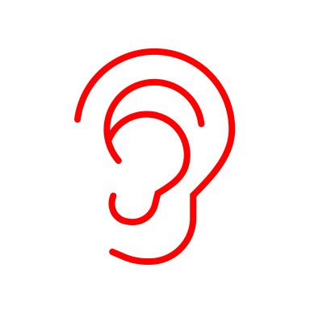
Hearing


Touch

My Sensory Diet
Scheduled activities:

Environmental adaptations:

Sensory play and learning:
Sensory Input | Sensory aversives (Assess)  ‘I may avoid’ | Sensory preferences (Assess)  ‘I may seek’ | What helps me regulate (Plan/Do)
Vestibular

(balance, position, and movement)

Proprioception (awareness of my body in space and how it moves)



Interoception (internal body awareness)


Additional information

Example Early Years Sensory Plan
My Sensory Plan  Date: June 2025 | Name | XXX | DOB | XXX
My Sensory Plan  Date: June 2025 | Completed by | XXX | Review date | Sept 2025
Photo of my preferred sensory resources
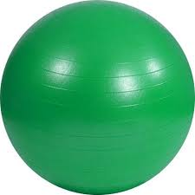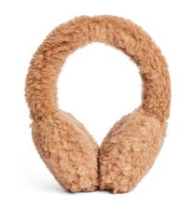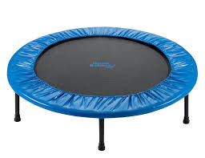

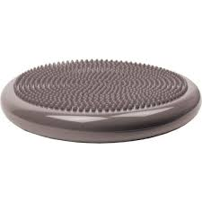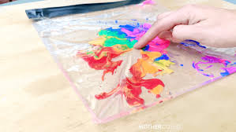

Sensory Input | Sensory aversives (Assess)  ‘I may avoid’ | Sensory preferences (Assess)  ‘I may seek’ | What helps me regulate (Plan/Do)
Sight | - Busy visual environments distracting  - Artificial lights | - Dark/dim spaces | - Low-arousal workspace  - Dim lighting  - Dark den
Smell |  | - Lavender  - Smell objects/people deeply | - Scented playdoh  - Fabrics scented with lavender to calm  - Blanket from home to smell when distressed
Taste |  | - Crunchy snacks | - Snacks from home throughout the day  - Will request snacks using visual symbol  - Favourites: crisps/crackers
Hearing | - Loud and sudden noises  - Busy times (including tidy up time music) |  | - Ear muffs  - Access to quiet area at busy times  - Use visuals to gain attention (avoid shouting/loud clapping etc.)
Touch | - New textures and materials  - Dirty hands  - Some messy play | - Hand washing | - Put new messy play items/resources in a zippy bag for me to explore  - Give gloves or a paintbrush to explore materials with

My Sensory Diet
Scheduled activities:
Sensory circuits (daily)

Environmental adaptations:
Quiet/low-arousal area
Wobble cushion on carpet

Sensory play and learning:
Don’t force messy play
Provide gloves/zippy wallets/hand washing facilities
Access to gym ball and trampette before focus activity
Sensory Input | Sensory aversives (Assess)  ‘I may avoid’ | Sensory preferences (Assess)  ‘I may seek’ | What helps me regulate (Plan/Do)
Vestibular  (balance, position, and movement) | - Sitting for long periods (e.g. carpet time) | - Climbing  - Jumping  - Hanging upside down | - Wobble cushion on carpet  - Daily sensory circuits  - Access to trampette as needed and before focussed activities
Proprioception (awareness of my body in space and how it moves) |  | - Deep pressure  - Hugs  - Small spaces | - Daily sensory circuits  - Offer to wrap in blanket when distressed  - Access to gym ball to roll on as needed
Interoception (internal body awareness) |  | - High pain threshold  - Under-sensitive to temperature | - Check regularly for scrapes/bumps/bruises or other injury  - Use visuals to support me with appropriate dress for the temperature (e.g. coat on/sun hat on/jumper off)

Additional information
Link to sensory circuit plan

