School Age Sensory Plan
My Sensory Plan  Date: | Name |  | DOB
My Sensory Plan  Date: | Completed by |  | Review date
Hyposensitivities (I may seek)
Sight:
Smell:
Taste:
Hearing:
Touch:
Vestibular:
Proprioception:
Interoception:

Hypersensitivities (I may avoid)
Sight:
Smell:
Taste:
Hearing:
Touch:
Vestibular:
Interoception:
Photo of my preferred sensory resources

Sensory Toolkit (Plan/Do)
[E.g. equipment, resources]
Sensory Adaptations (Plan/Do)
[E.g. scheduled activities, environmental adaptations, lesson passes, adaptations to school policies such as uniform]

Additional information

Example School Age Sensory Plan (1)
My Sensory Plan  Date: June 24 | Name | XXX | DOB | XXX
My Sensory Plan  Date: June 24 | Completed by | XXX | Review date | Oct 24
Hyposensitivities (I may seek)
Sight: natural light
Smell: natural smells (flowers/fresh air); lip balm
Taste:
Hearing: quiet environments
Touch: wearing a hoodie/hand cream
Vestibular: being still/being wrapped up
Proprioception: deep pressure/secure seating

Hypersensitivities (I may avoid)
Sight: strip lighting
Smell: bleach/chemicals in science lab
Taste:
Hearing: buzzing electrical equipment/noisy machines in DT
Touch: sticky science benches/school tie
Vestibular: spinning/ standing up quickly/stools/busy corridors

Photo of my preferred sensory resources
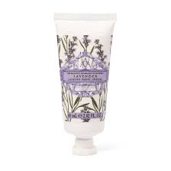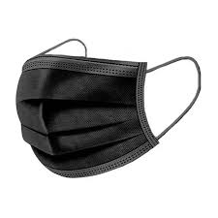
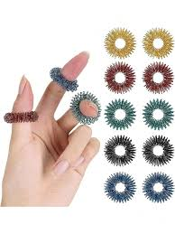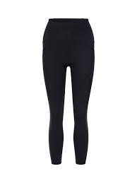

Sensory Toolkit (Do)
Ear plugs
Wear a mask in science lessons
Antibac wipes
Scented hand cream
Lip balm
Alternative seating in science
Compression tights/top under uniform
Spiky sensory ring

Sensory Adaptations (Plan/Do)
Alternative activities during PE (walk round field/homework club/refereeing)
Morning access to low-arousal space
Seat by window/in a quiet part of classroom
Time out pass
Uniform adaptations (clip on tie/top button undone/can wear PE kit instead of uniform)

Additional information
Prewarn of science practicals
Will indicate sensory overwhelm using time out pass

School Age Sensory Plan (2)
Sensory Stimuli | Hypersensitivities  (I may avoid) | Hyposensitivities  (I may seek) | Strategies

Sight

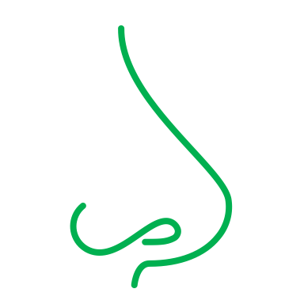
Smell
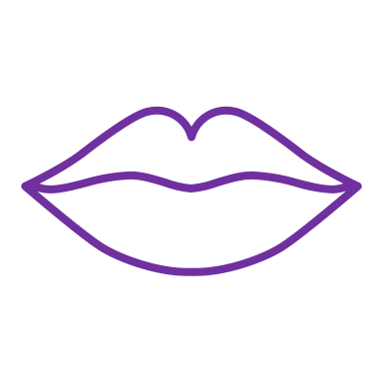
Taste

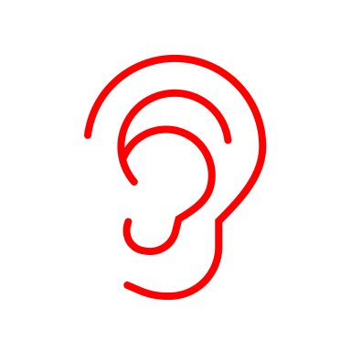
Hearing

Touch
Vestibular

(balance and movement)

Proprioception (awareness of my body in space)

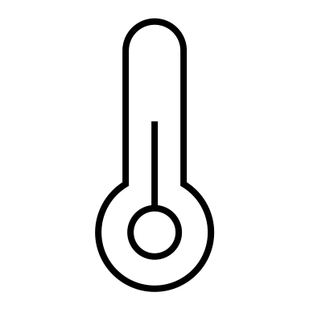
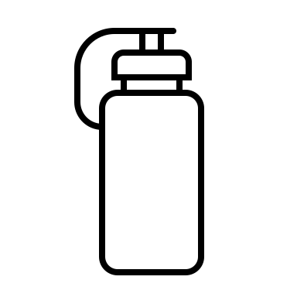
Interoception (internal body awareness)
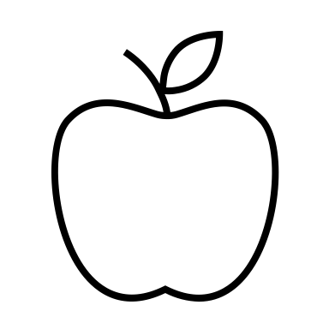
My Sensory Plan  Date: | Name |  | DOB
My Sensory Plan  Date: | Completed by |  | Review date

Example School Age Sensory Plan (2)
Sensory Stimuli | Hypersensitivities  (I may avoid) | Hyposensitivities  (I may seek) | Strategies
Sight | - Bright wall displays  - Bright lights |  | - Low lighting  - Tinted glasses  - Clear desk and walls at my workstation
Smell | - Smell of fish and egg | - Smell of people I like  - Washing powder  - Perfume | - Blanket from home  - Scented pens  - Knowing lunch menus and food tech activities ahead of time
Taste | - Strong food preferences and aversions |  | - Packed lunch from home  - Don’t force trying new foods  - Make sure lunchtime staff aware of aversions
Hearing | - Loud noises  - Background noise in class/Shouting out  - Music in assembly |  | - Seat in quiet area and near door (in class and assembly)  - Ear defenders  - Time out card
Touch |  | - Fluffy and fleecy fabrics  - Touching/stroking the arms of other people | - Blanket from home to stroke  - Sensory strips on desk  - Bag of sensory tools in tray
Vestibular  (balance and movement) |  | - Spinning  - Tipping head back  - Swinging on chair | - Movement breaks  - Seat by a wall  - Alternative seating (wobble stool/computer chair)
Proprioception (awareness of my body in space) |  | - Sit on my feet/knees  - Deep pressure | - Weighted lap belt  - Blanket from home  - Seat by a wall
Interoception (internal body awareness) |  | - Don’t always notice if I need to use the bathroom  - Will forget to drink/eat | - Reminders and scheduled toilet breaks  - Toilet pass  - Reminders to eat/drink
My Sensory Plan  Date: Jun 25 | Name | XXX | DOB | XXX
My Sensory Plan  Date: Jun 25 | Completed by | XXX | Review date | Oct 25

